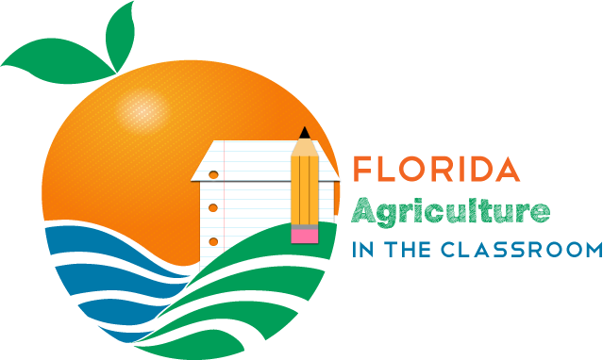
PO Box 110015
Gainesville, FL 32611
(352) 846-1391
FAX (352) 846-1390
www.agtag.org

Florida Agriculture in the Classroom, Inc. 2020-2021 Teacher Grants

Statement of Intent:
Florida Agriculture in the Classroom’s Teacher Grant program strives to fund classroom projects that teach Florida school children about the importance of agriculture and introduce them to agricultural producers and representatives in their areas.

Timeline:
- All proposals must be emailed on or before January 31, 2021.
- ONLY the first 40 complete applications will be accepted and considered.
- FAITC will announce grant recipients by email before the end of February 2021.
- Online progress reports are due to FAITC by March 26, 2021.
- The final report must be completed online or postmarked on or before June 15, 2021.

Eligible Applicants:
Certified Florida teachers engaged in classroom instruction at the pre-kindergarten through 12th grade levels who integrate agricultural concepts into their curriculum.

Grant Requirements:
- Agricultural concepts & student involvement are required.
- FAITC/AITC materials must be included or justification as to why they are not being incorporated.
Project must include a lesson or activity from Florida Agriculture in the Classroom’s resources or National Agriculture in the Classroom. To access Florida Agriculture in the Classroom’s resources visit https://faitc.org/teaching-resources/. To access National Agriculture in the Classroom’s Curriculum Matrix visit https://agclassroom.org/matrix/. If your project does not have FAITC/AITC curriculum please explain the education piece in your application.
- Photo Documentation that shows the location of the project must be included. A drawing on the image for clarification is recommended.
- At least one Florida farmer or agriculture industry representative must be involved.
- A letter of support from a school administrator on school letter head with signature must be included in the application.
- Teachers must complete pre and post evaluations and include the results in the final report. These will vary depending on grade level. There are sample tests with most of our lessons in our three school garden curriculums.
- Community involvement in the project is encouraged (this is over and above the local farmer or ag industry representative stated above).

Funding Guidelines: A sample budget is located in Appendix C.
- Transportation will only be considered in situations where a justifiable need is demonstrated in the application.
- Grant funding cannot go towards salaries or similar compensation.
- Amount requested can be no larger than $5,000.
- Grant projects awarded $1,000 or more may re-apply up to three times consecutively.
- Grant money cannot be used for consumables unless the food items are an integral part of the lesson plan and the end product.
- Grant checks not cashed within 60 days after receipt will become null and void.
- Usually half of the funds are paid up front and the other half is paid when the progress report is submitted but due to the shortened funding period all money will be given up front. A final report must be submitted by the deadline or future grant requests automatically will be denied.
- Grant checks will be made payable to the school, not to an individual.

Grant Rubric: 100 points possible. A detailed rubric is located in Appendix B.

Points | Criteria
25 | Project Description and Purpose:  Up to 25 points will be given based on the ability to effectively convey your project’s why and how.
20 | Measurable Outcomes:  Up to 20 points will be given based on realistic, attainable, and challenging goals related to the project’s purpose. Goals can be qualitative and quantitative.
20 | Timeline:  Up to 20 points will be given based on the detail given in the timeline.
20 | Budget:  Up to 20 points will be given based on the detail given in the budget.
10 | Creativity and innovation in the project’s ability to address Florida agriculture:  Up to 5 points awarded.
5 | Education standards addressed:  Up to 5 points awarded.

Management and Reporting
- Brief online summary of project progress or email survey is due on or before March 26, 2021.
- Florida Agriculture in the Classroom grant final reports must include related materials in a printable format, at least 5 photos showing project, photo release form for all students whose faces are in pictures and copies of all receipts that equal awarded amount.
- The final report should include the number of students the project actually reached and the FAITC/AITC lessons taught and the results of the pre- and post-evaluations.
- The final report is due by June 15, 2021.
- Failure to comply with these reporting requirements will result in the automatic removal of the teacher from consideration for future grant requests.

Format for Proposals: A word document application form is located in Appendix A.
- Application must be typed on 8.5”x11” paper, 1.5” or doubled spaced and in 11 or 12-point font type. (Proposals can be typed directly on the application provided or that form can be duplicated in a word processing program.)
- The submitted proposal is limited to the five-page application form (Appendix A). Page 1 and 2 must be exactly the same as format in Appendix A. If your budget and timeline need an additional page, we will accept up to seven pages. The final page is for your photo documentation.
- The letter of support from a school administrator is mandatory to be considered for the grant.
- Submit entire proposal via email as one PDF file.

Proposal Submission
The deadline for submitting grant proposals to the Florida Agriculture in the Classroom office is January 31, 2021. We will only be considering the first 40 applications that we receive that are 100% complete.

Completed proposals should be emailed to Becky Sponholtz at sponholtz@agtag.org

Questions: Contact Becky Sponholtz by calling (352) 846-1391, emailing sponholtz@agtag.org or visiting https://faitc.org/teacher-grants/.

